**PASSPORT AUTOMATION SYSTEM**

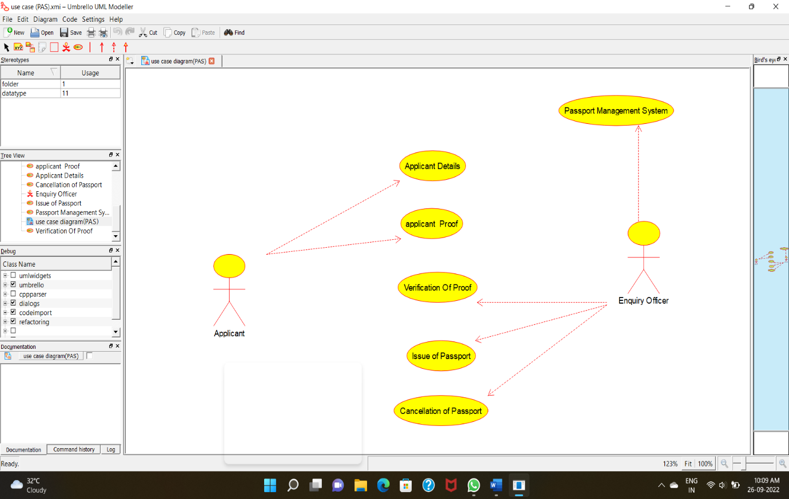**USE CASE DIAGRAM:**

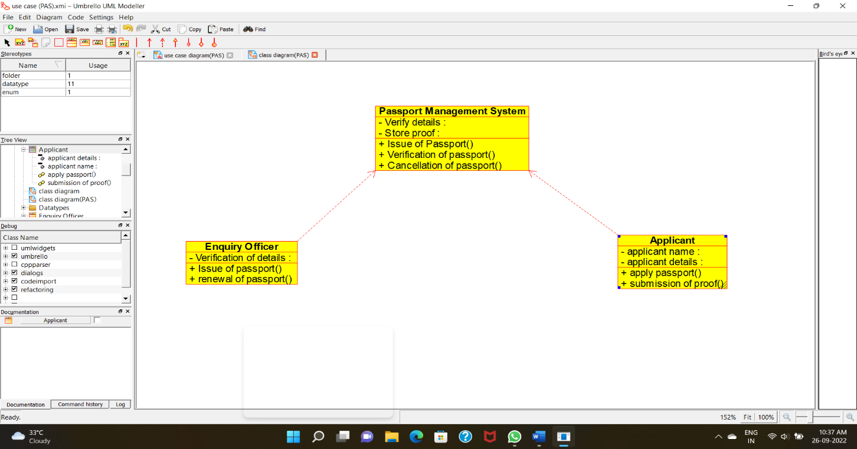**CLASS DIAGRAM:**

**ACTIVITY DIAGRAM:**

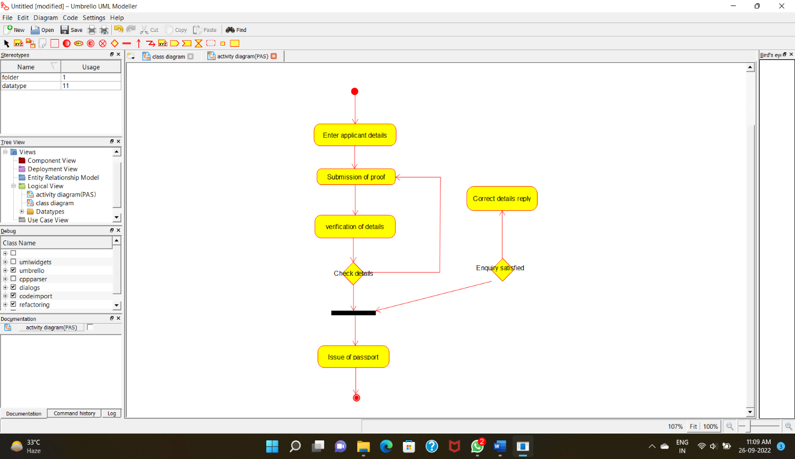

**SEQUENCE DIAGRAM:**

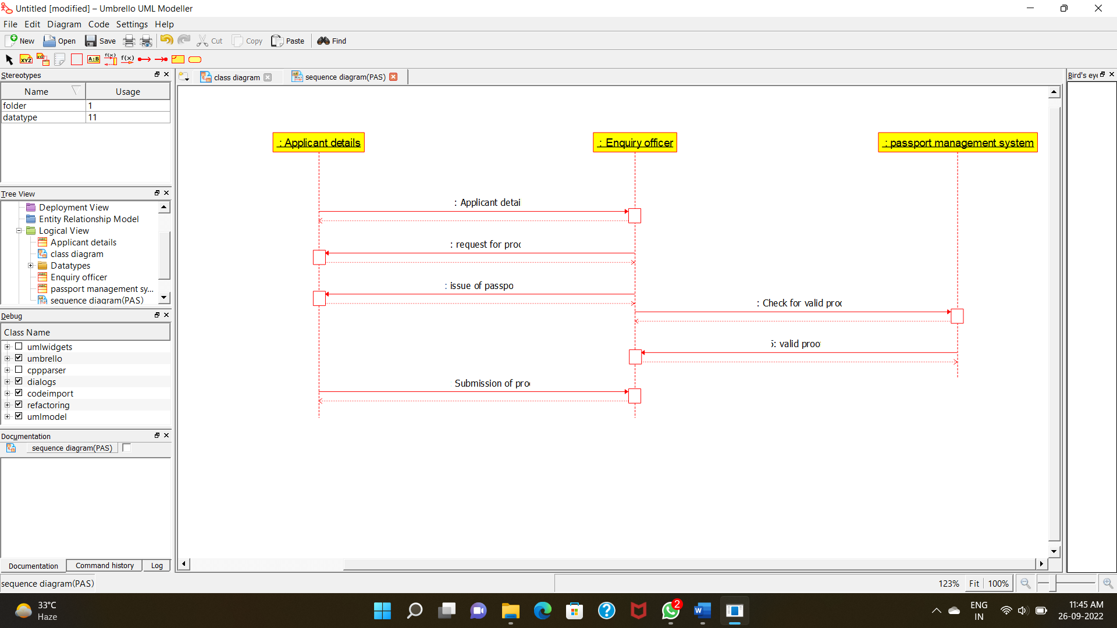

**COLLABORATION DIAGRAM:**

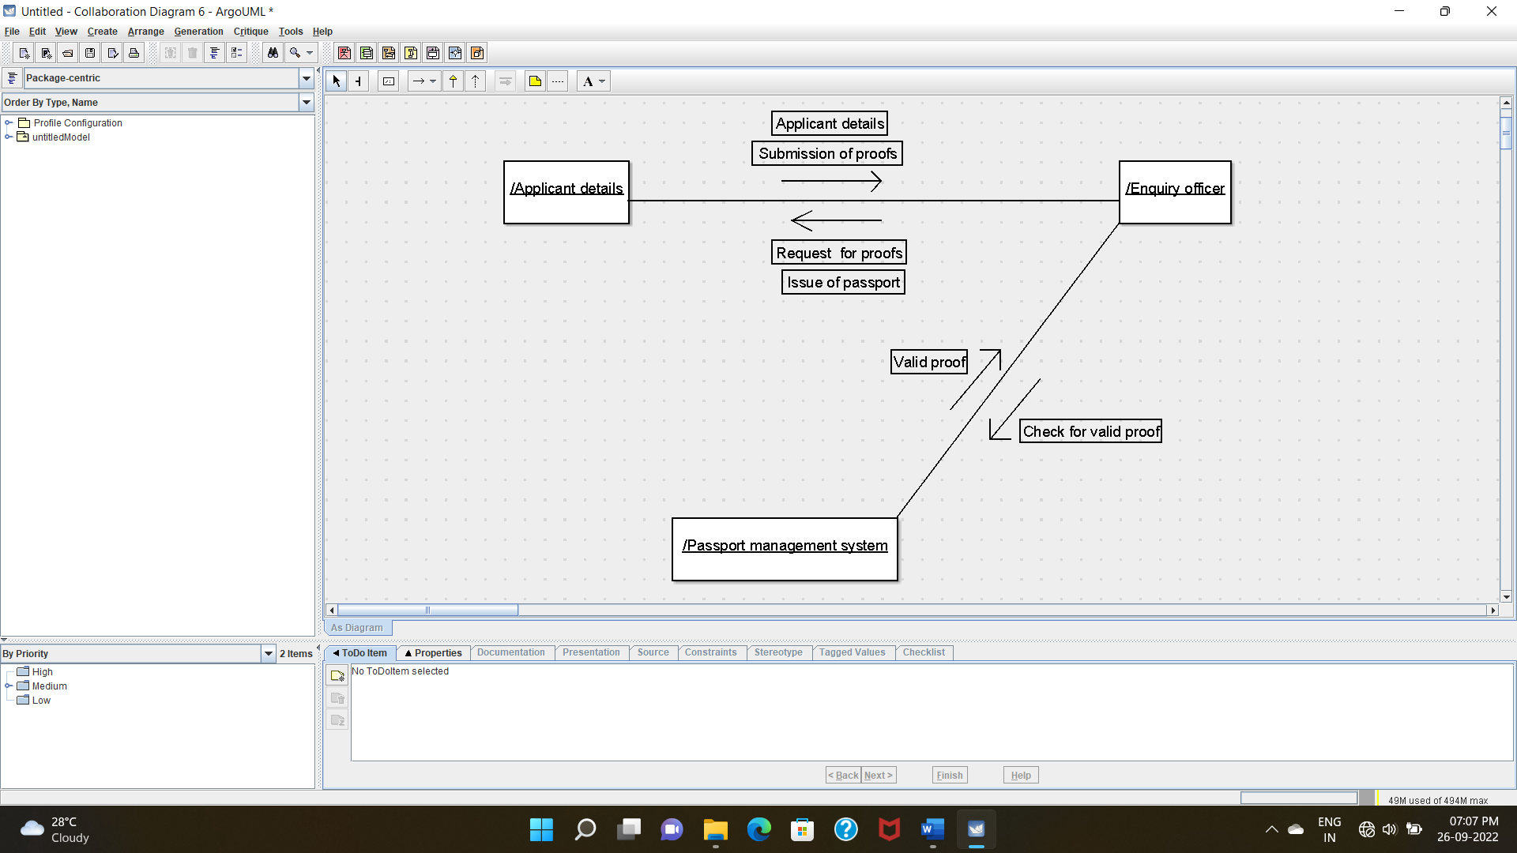

**STATE CHART DIAGRAM :**

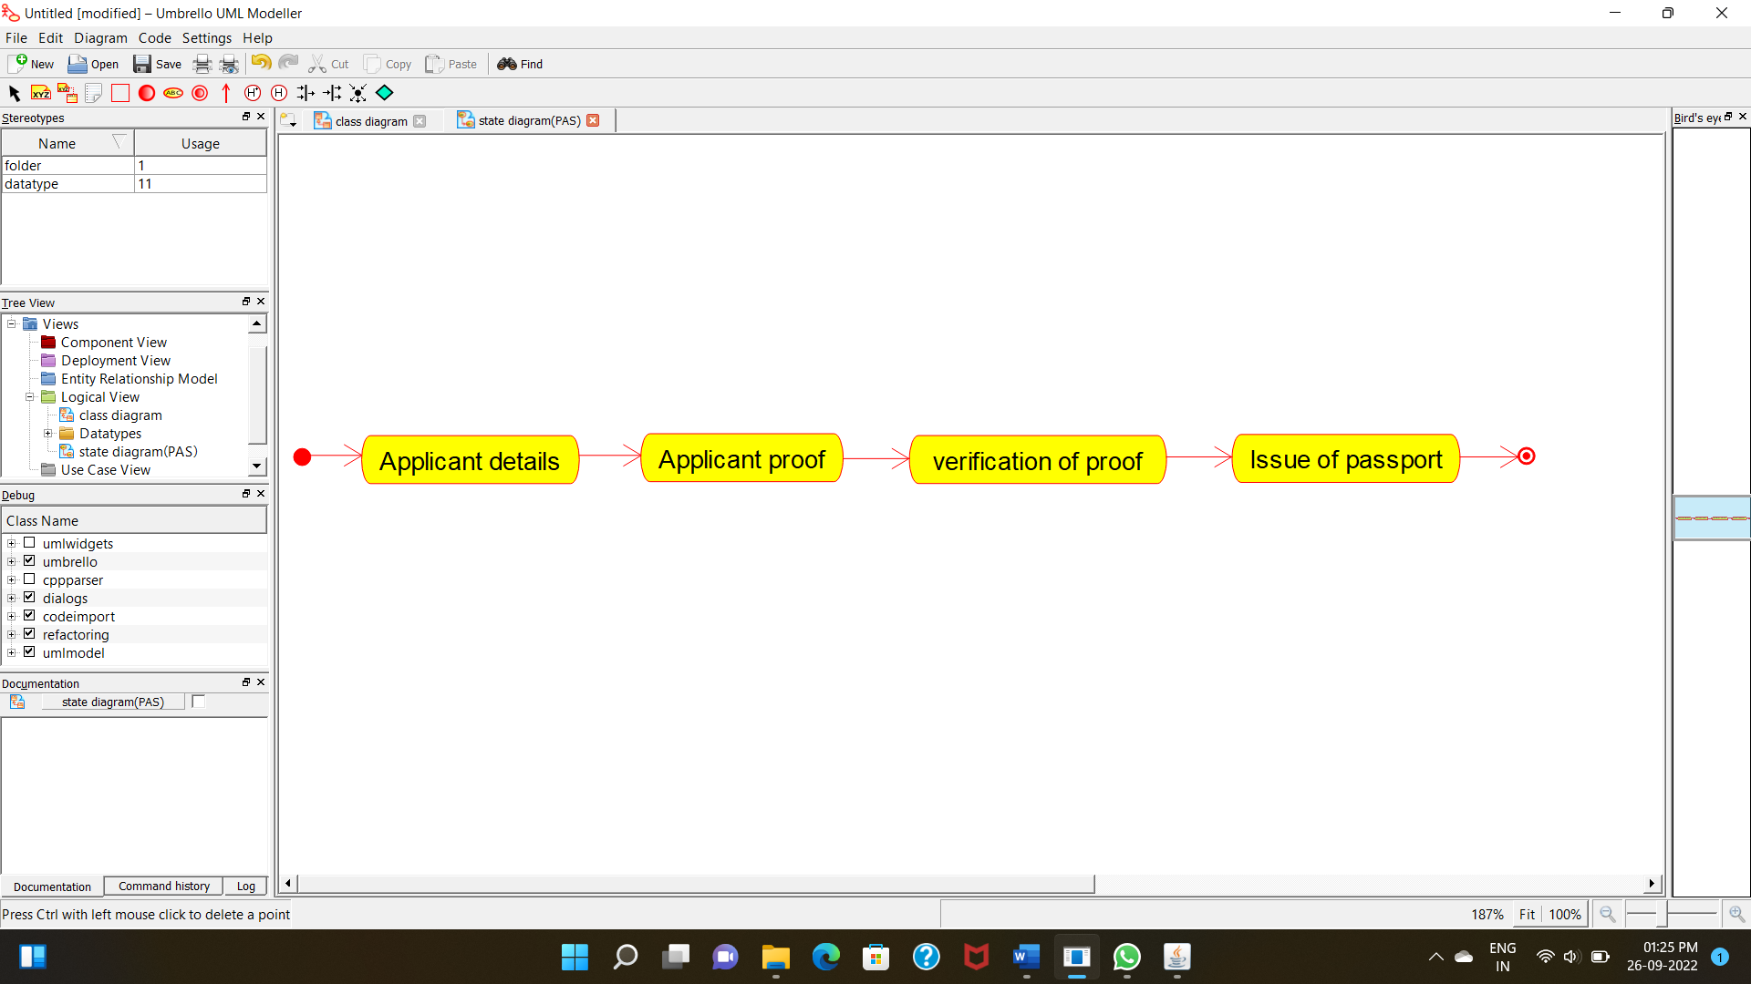

**COMPONENT DIAGRAM**

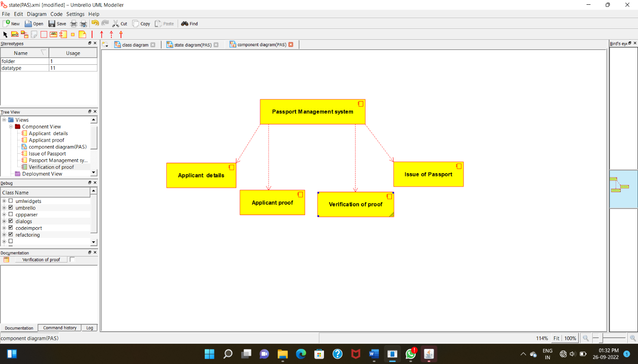

**DEPLOYMENT DIAGRAM**

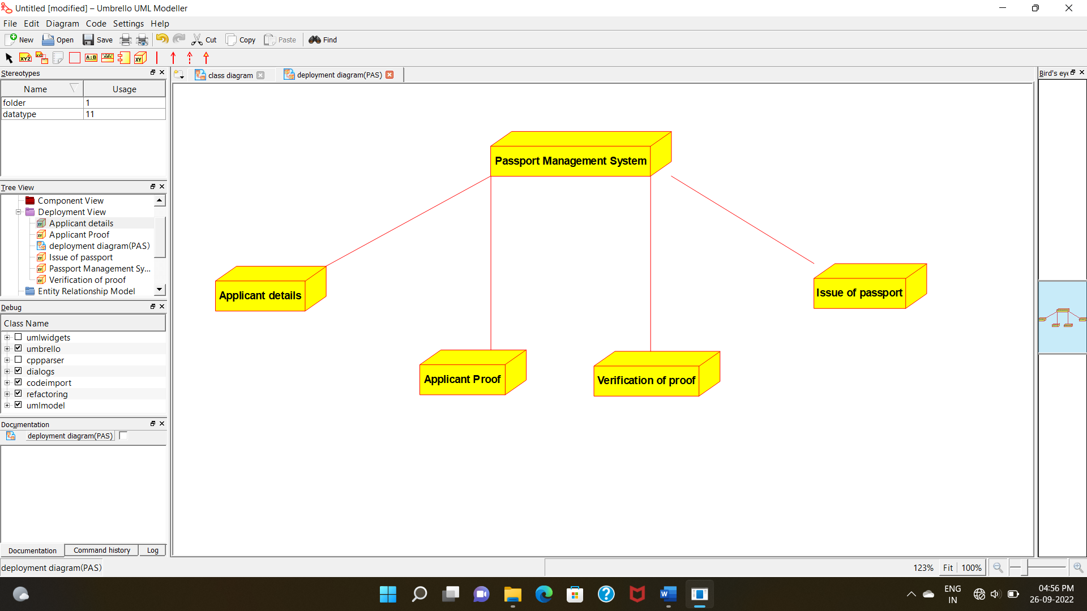

**PACKAGE DIAGRAM:**

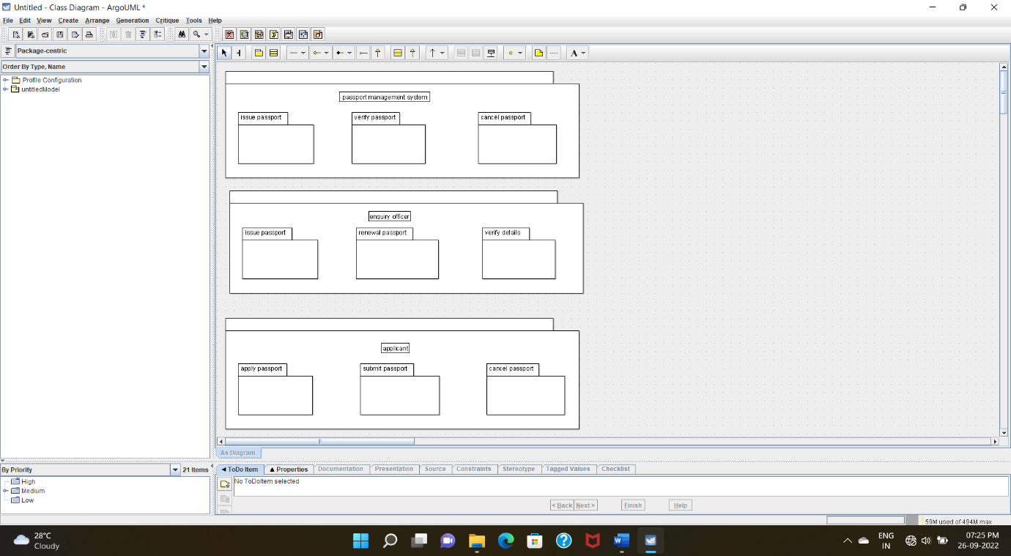

**PROGRAM CODING:**

**PASSPORT MANAGEMENT SYSTEM:**

/**

* Class Passport_management_system

*/

public class Passport_management_system {

//

// Fields

//

private void verify_details;

private void store_proof;

//

// Constructors

//

public Passport_management_system () { };

//

// Methods

//

//

// Accessor methods

//

/**

* Set the value of verify_details

* @param newVar the new value of verify_details

*/

private void setVerify_details (void newVar) {

verify_details = newVar;

}

/**

* Get the value of verify_details

* @return the value of verify_details

*/

private void getVerify_details () {

return verify_details;

}

/**

* Set the value of store_proof

* @param newVar the new value of store_proof

*/

private void setStore_proof (void newVar) {

store_proof = newVar;

}

/**

* Get the value of store_proof

* @return the value of store_proof

*/

private void getStore_proof () {

return store_proof;

}

//

// Other methods

//

/**

*/

public void issue_of_passport()

{

}

/**

*/

public void verification_of_passport()

{

}

/**

*/

public void cancellation_of_passport()

{

}

}

**ENQUIRY OFFICER:**

**/\*\***

**\* Class Enquiry_officer**

**\*/**

**public class Enquiry_officer {**

**//**

**// Fields**

**//**

**private void verification_of_details;**

**//**

**// Constructors**

**//**

**public Enquiry_officer () { };**

**//**

**// Methods**

**//**

**//**

**// Accessor methods**

**//**

**/\*\***

**\* Set the value of verification_of_details**

**\* @param newVar the new value of verification_of_details**

**\*/**

**private void setVerification_of_details (void newVar) {**

**verification_of_details = newVar;**

**}**

**/\*\***

**\* Get the value of verification_of_details**

**\* @return the value of verification_of_details**

**\*/**

**private void getVerification_of_details () {**

**return verification_of_details;**

**}**

**//**

**// Other methods**

**//**

**/\*\***

**\*/**

**public void issue_of_passport()**

**{**

**}**

**/\*\***

**\*/**

**public void renewal_of_passport()**

**{**

**}**

**}**

**APPLICANT:**

/**

* Class Applicant

*/

public class Applicant {

//

// Fields

//

private void applicant_name;

private void applicant_details;

//

// Constructors

//

public Applicant () { };

//

// Methods

//

//

// Accessor methods

//

/**

* Set the value of applicant_name

* @param newVar the new value of applicant_name

*/

private void setApplicant_name (void newVar) {

applicant_name = newVar;

}

/**

* Get the value of applicant_name

* @return the value of applicant_name

*/

private void getApplicant_name () {

return applicant_name;

}

/**

* Set the value of applicant_details

* @param newVar the new value of applicant_details

*/

private void setApplicant_details (void newVar) {

applicant_details = newVar;

}

/**

* Get the value of applicant_details

* @return the value of applicant_details

*/

private void getApplicant_details () {

return applicant_details;

}

//

// Other methods

//

/**

*/

public void apply_passport()

{

}

/**

*/

public void submission_of_proof()

{

}

}